**4.5CA251C01: DATA STRUCTURES LAB**

1. **Write a program in C to implement insertion in 1-D Arrays**
2. **Write a program in C to implement deletion in 1-D Arrays**
3. **Write a program in C to implement linear and binary searching in 1-D Arrays**
4. **Write a program in C to implement sorting in 1-D Arrays**

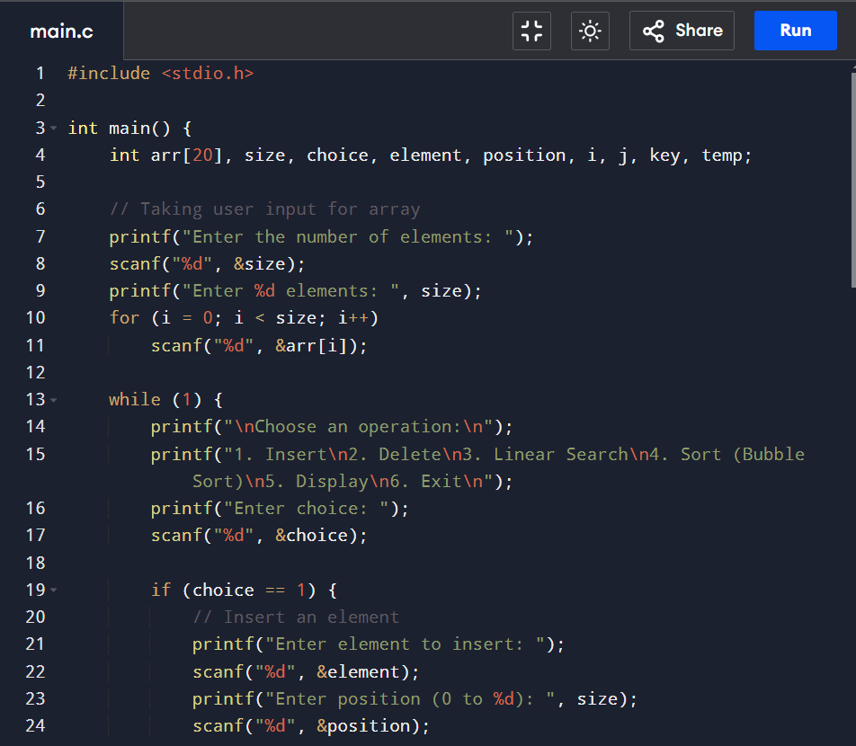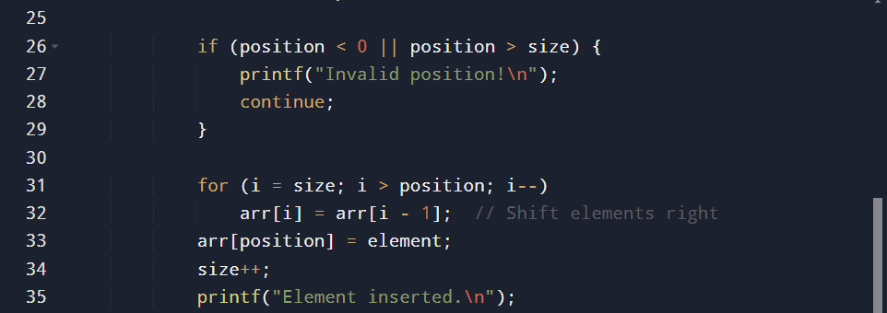

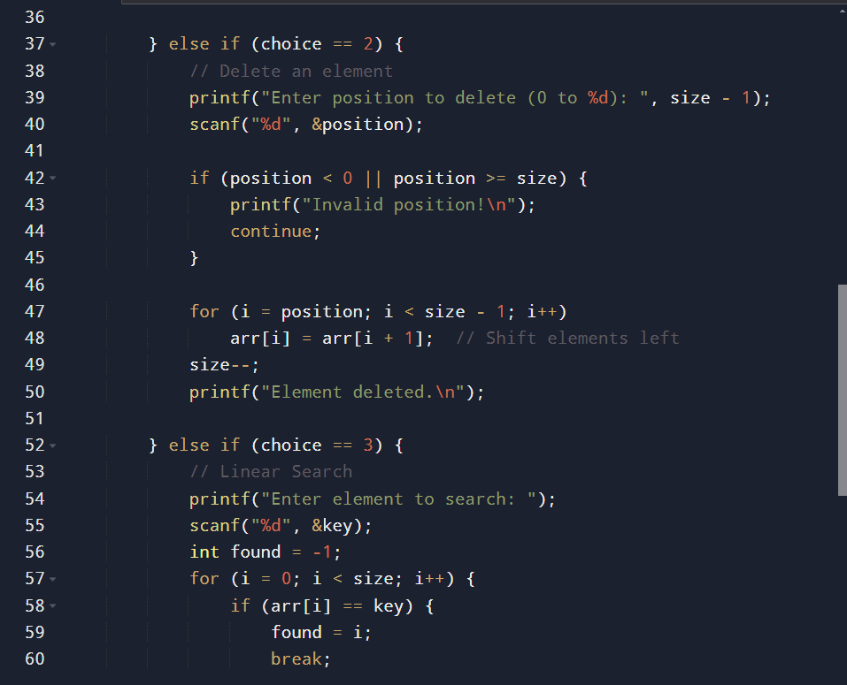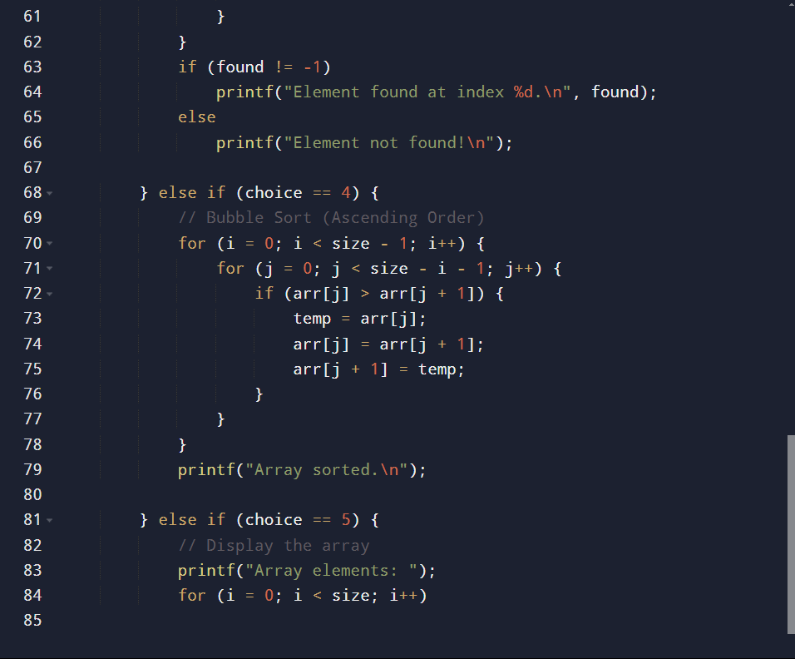

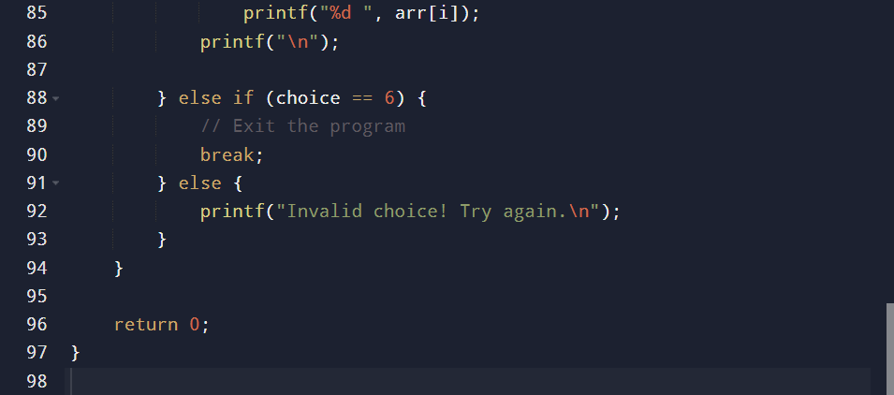

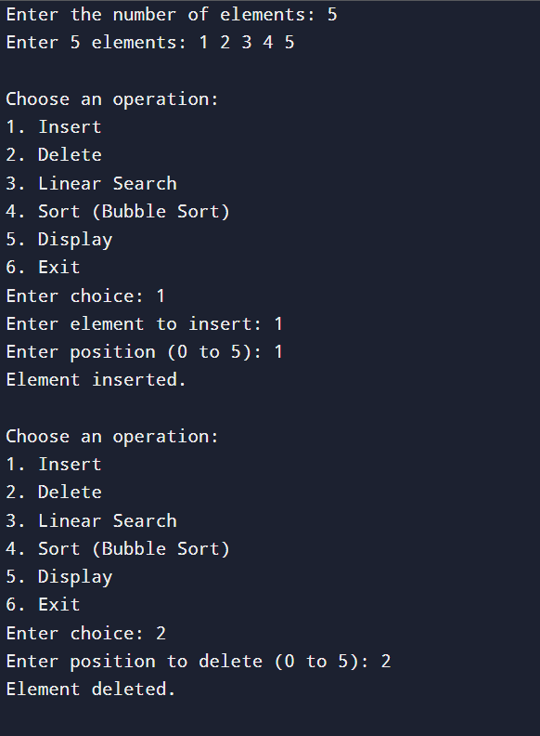

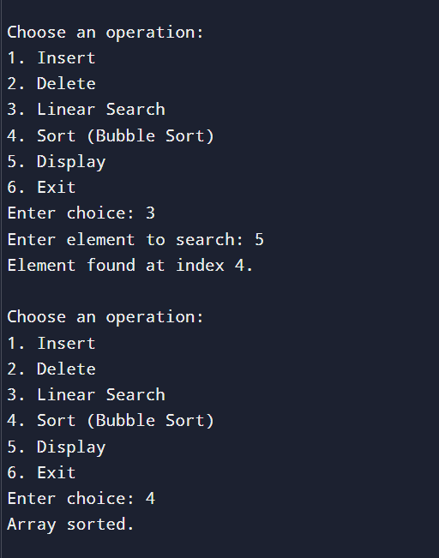

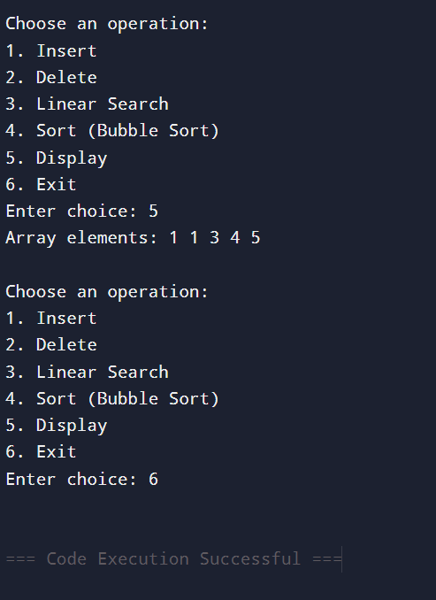

1. **Write a program in C to concatenate two arrays**

**What is Concatenation?**

**Concatenation** means **joining two things together**. In the context of **arrays**, it means **combining two arrays into one**.

**Example of Array Concatenation**

**Before Concatenation**

* **Array 1**: {1, 2, 3}
* **Array 2**: {4, 5, 6}

**After Concatenation**

* **New Array**: {1, 2, 3, 4, 5, 6} (combining both arrays)

It simply means **placing the elements of the second array right after the first one** in a new array.

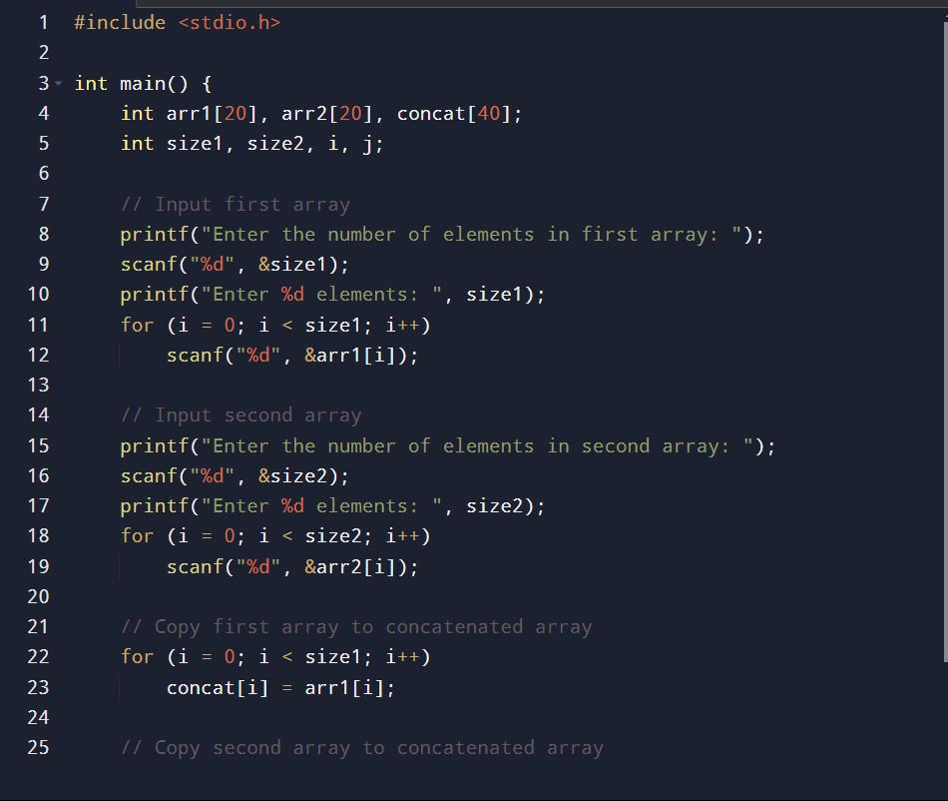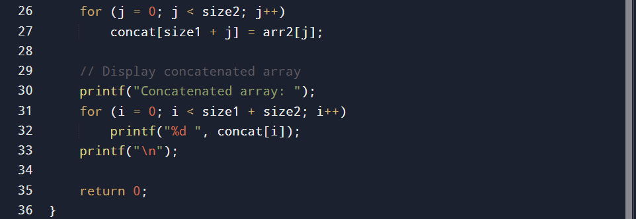

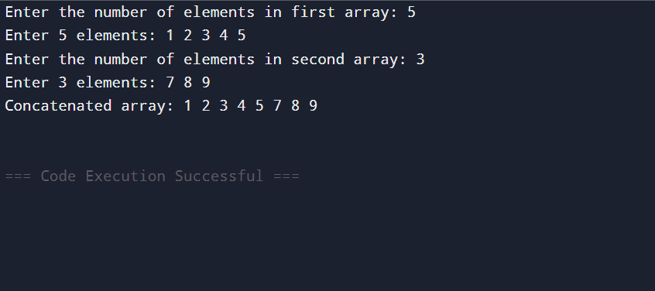

1. **Write a program in C to implement the following Operations on 2-D Array (addition; subtraction; multiplication; transpose)**

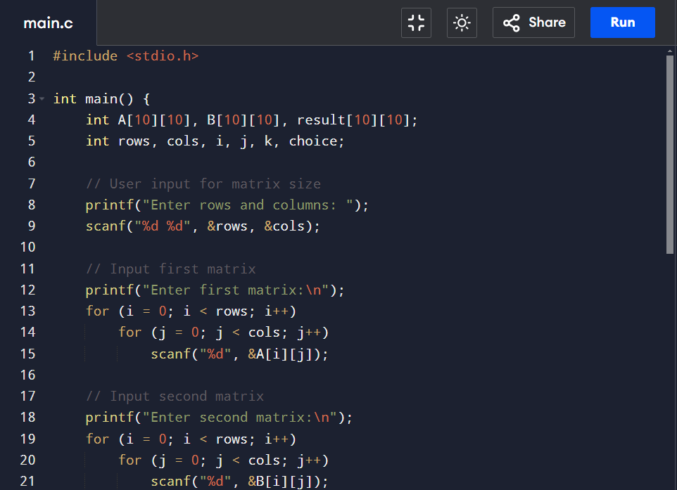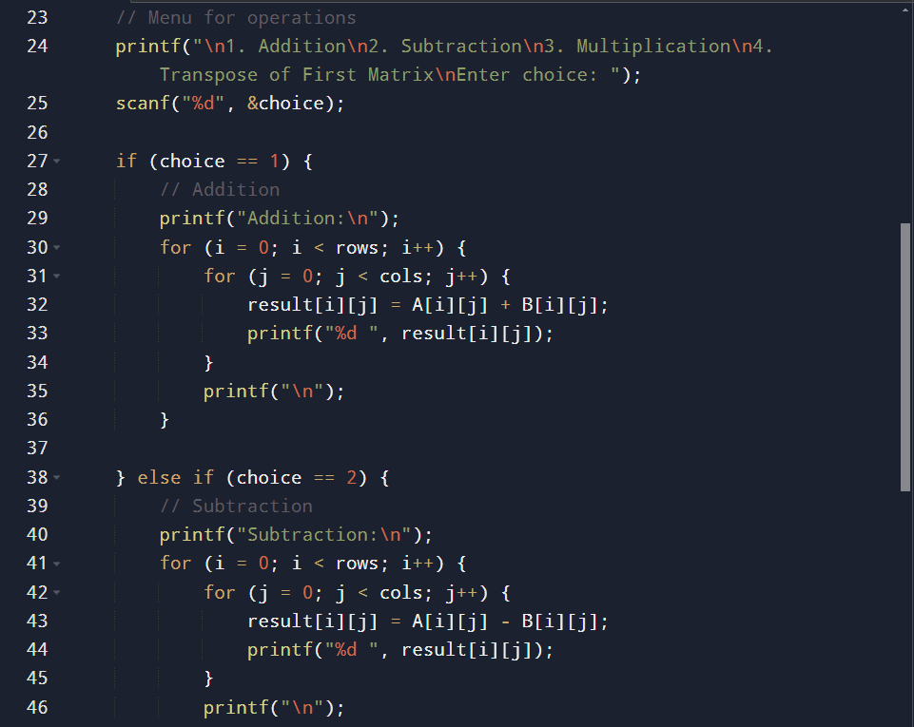

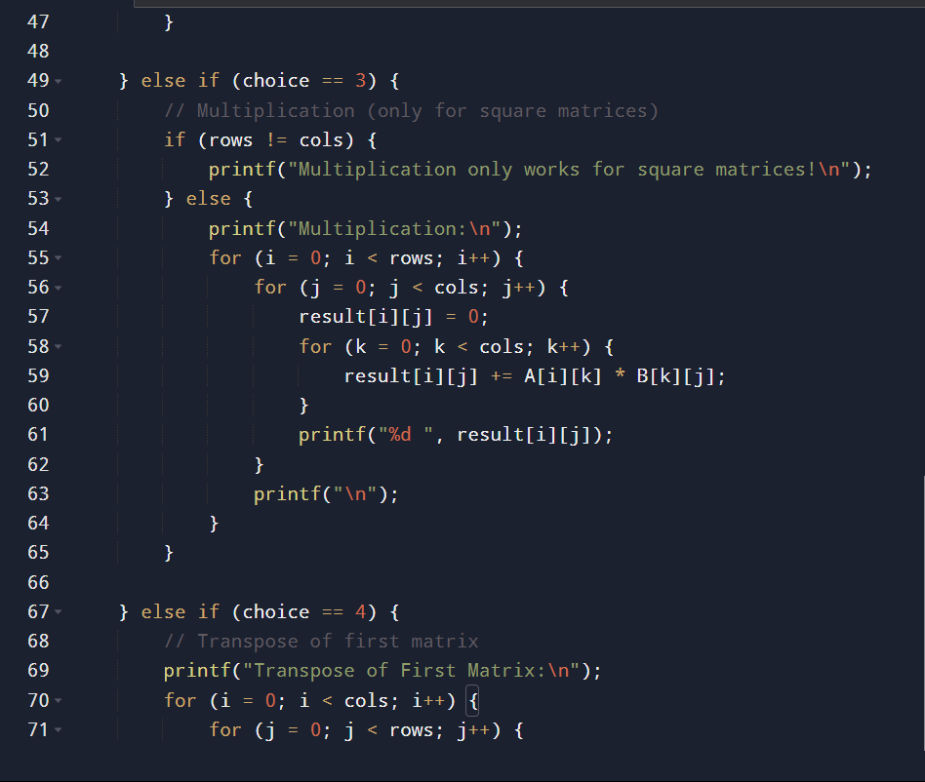

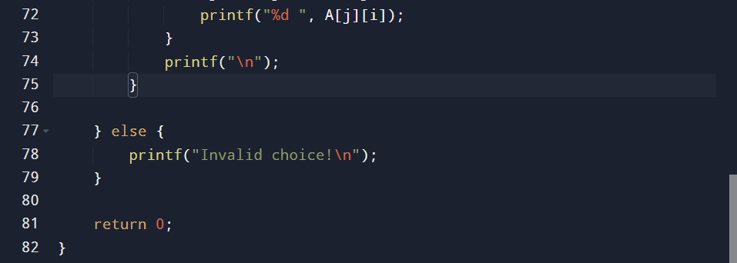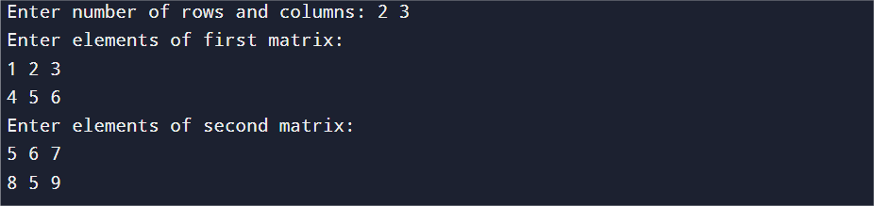

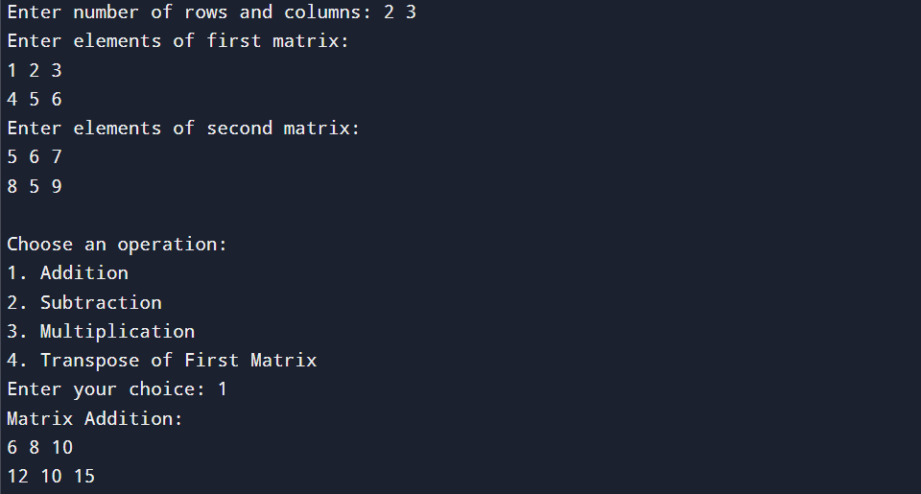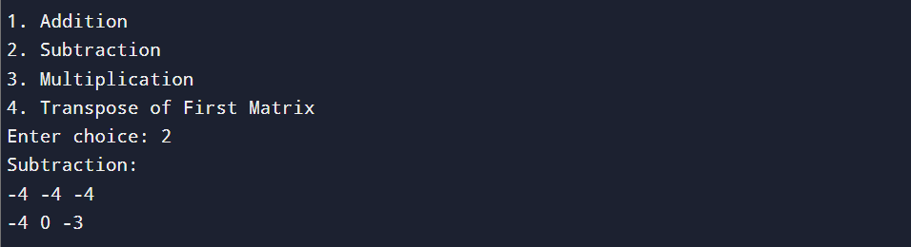

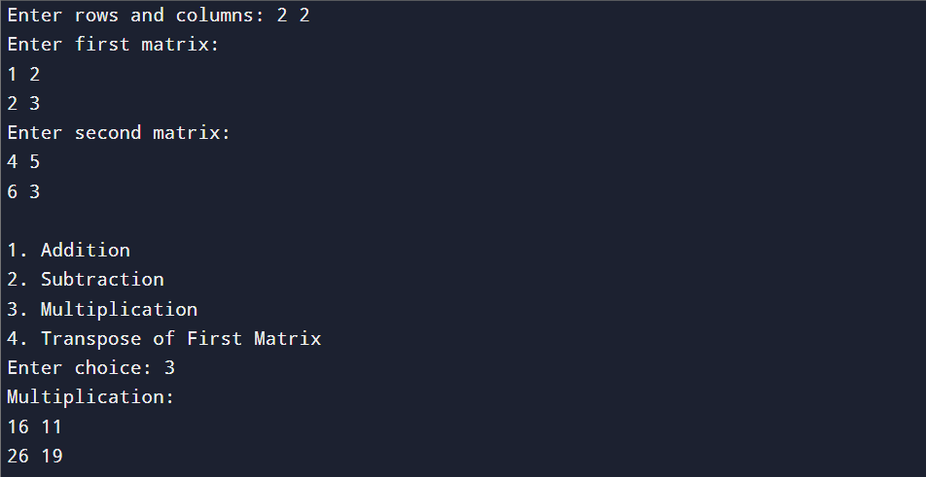

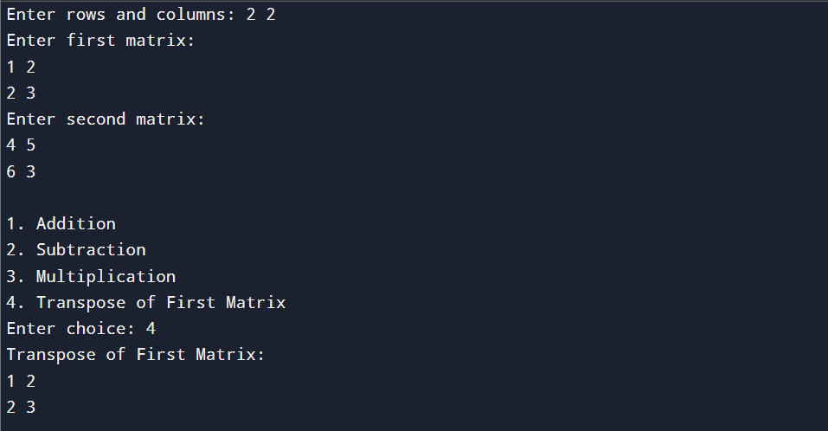

1. A computer screen shot of a program

   AI-generated content may be incorrect.A computer screen shot of a computer code

   AI-generated content may be incorrect.A screenshot of a computer program

   AI-generated content may be incorrect.All Operations of Stack (PUSH, POP, DISPLAY).
2. 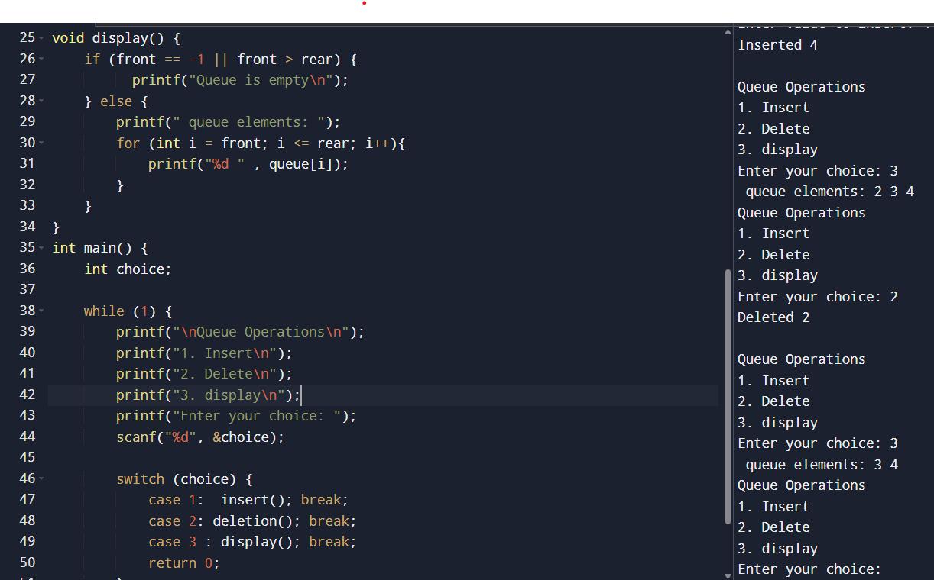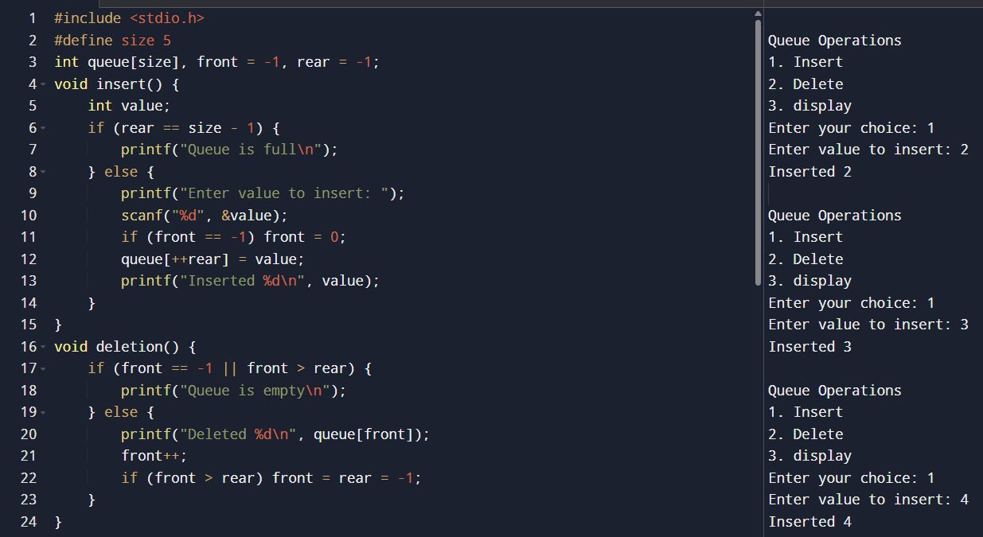All Operations of QUEUE (INSERTION, DELETION, DISPLAY).
3. A computer screen shot of a code

   AI-generated content may be incorrect.A screen shot of a computer program

   AI-generated content may be incorrect.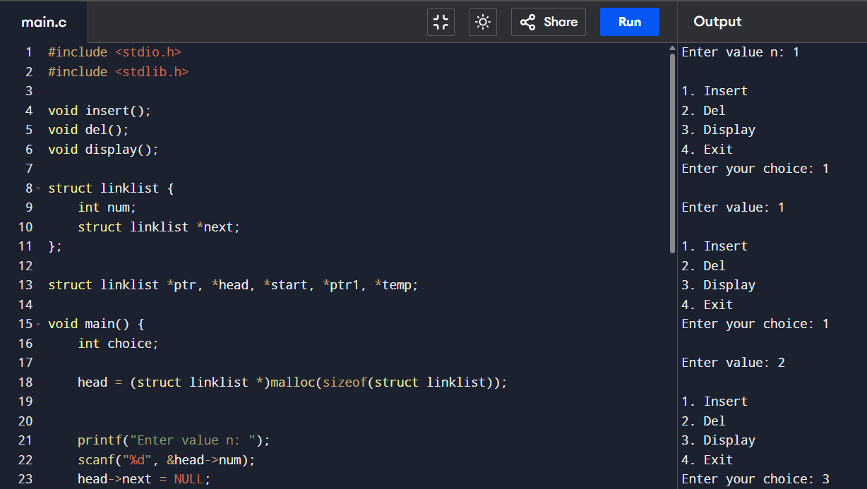Linked list
4. A screen shot of a computer screen

   AI-generated content may be incorrect.A screen shot of a computer

   AI-generated content may be incorrect.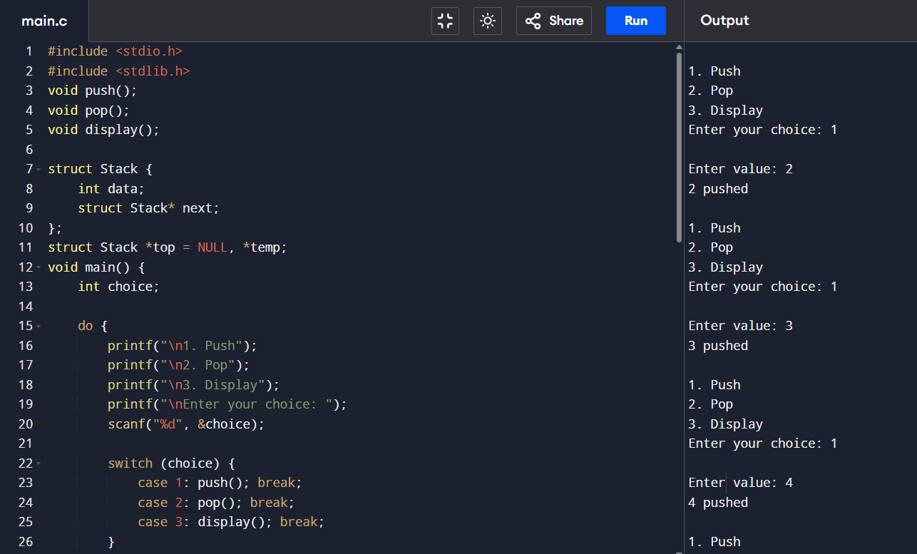 Stack through linked list.
5. 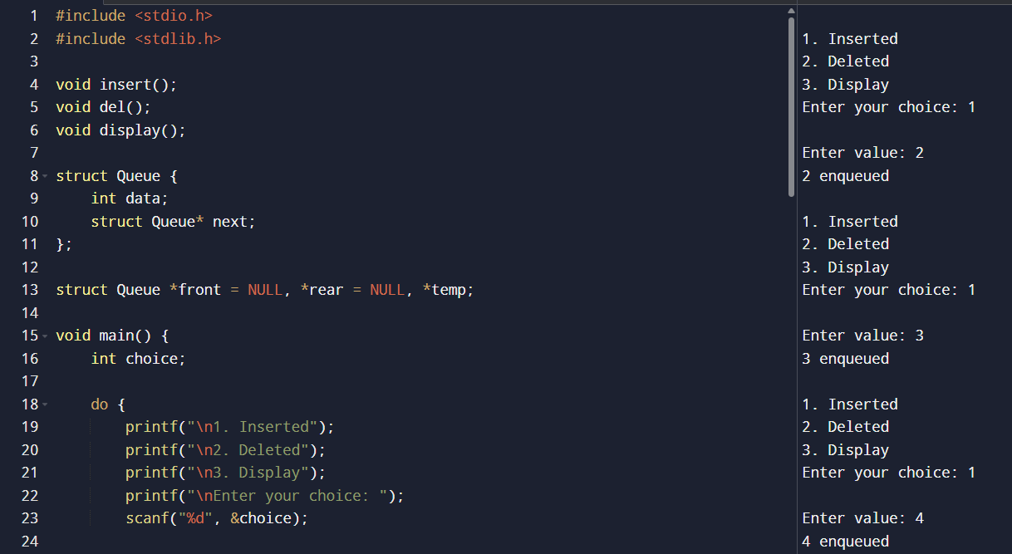A computer screen shot of a program

   AI-generated content may be incorrect. Queue through linked list.

